**Saravanan - Marketing Works**

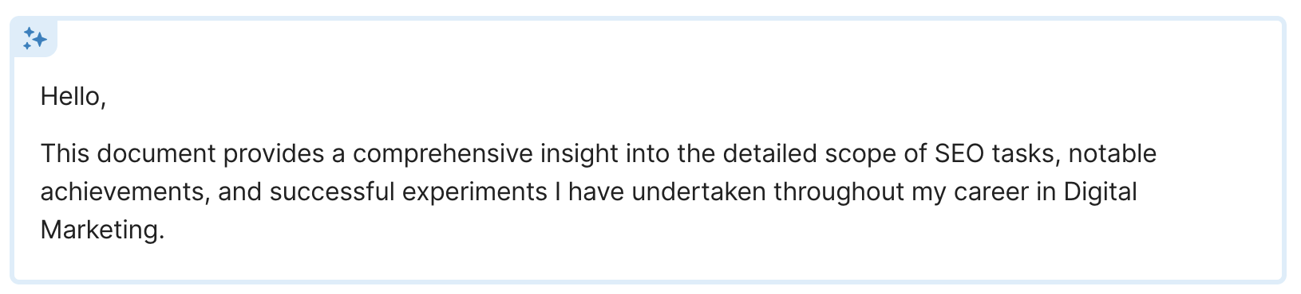

# **Traffic and Ranking Highlights**

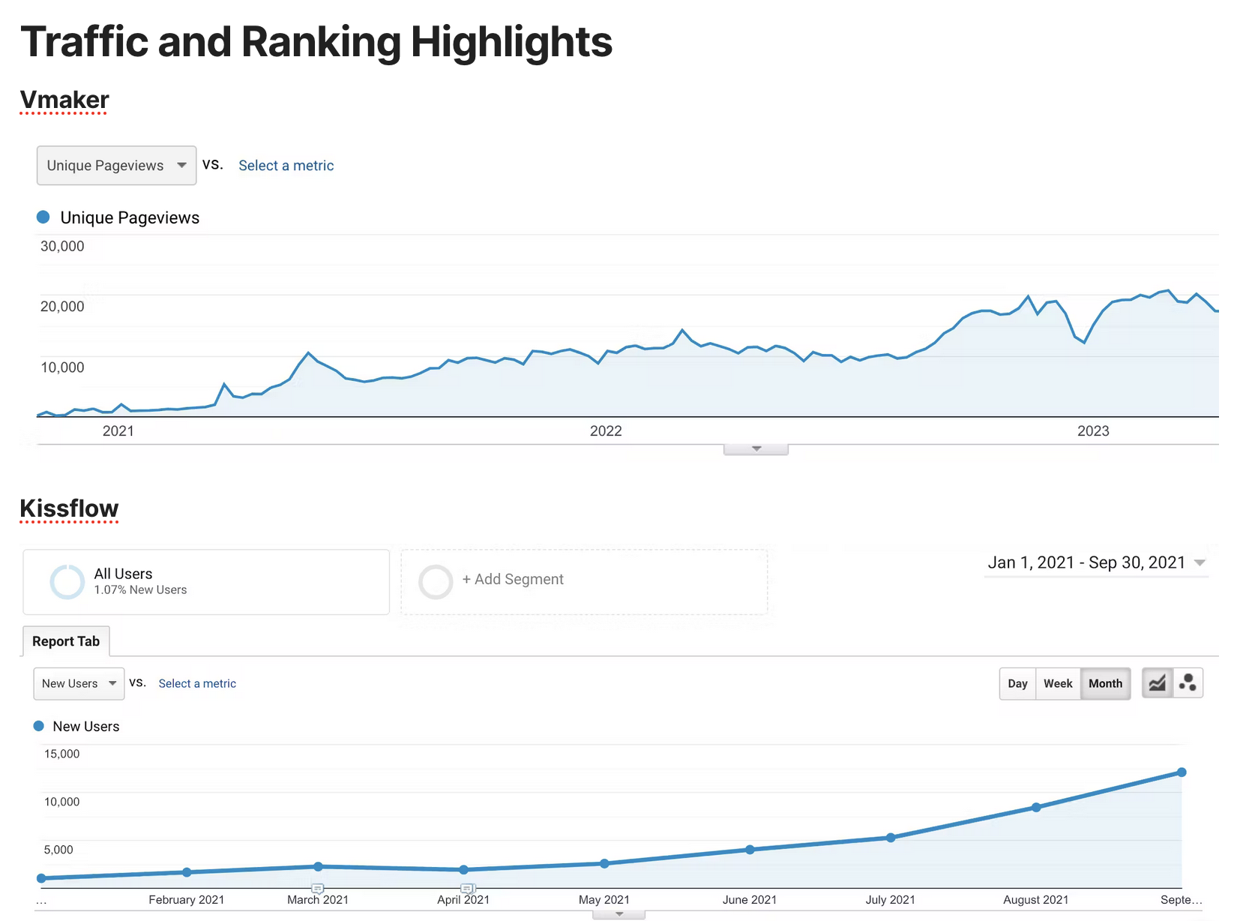

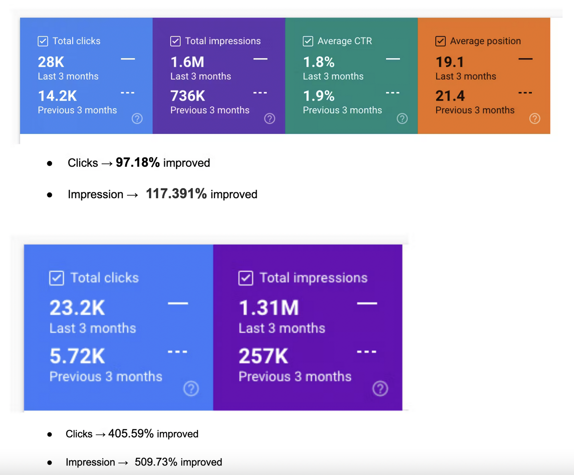

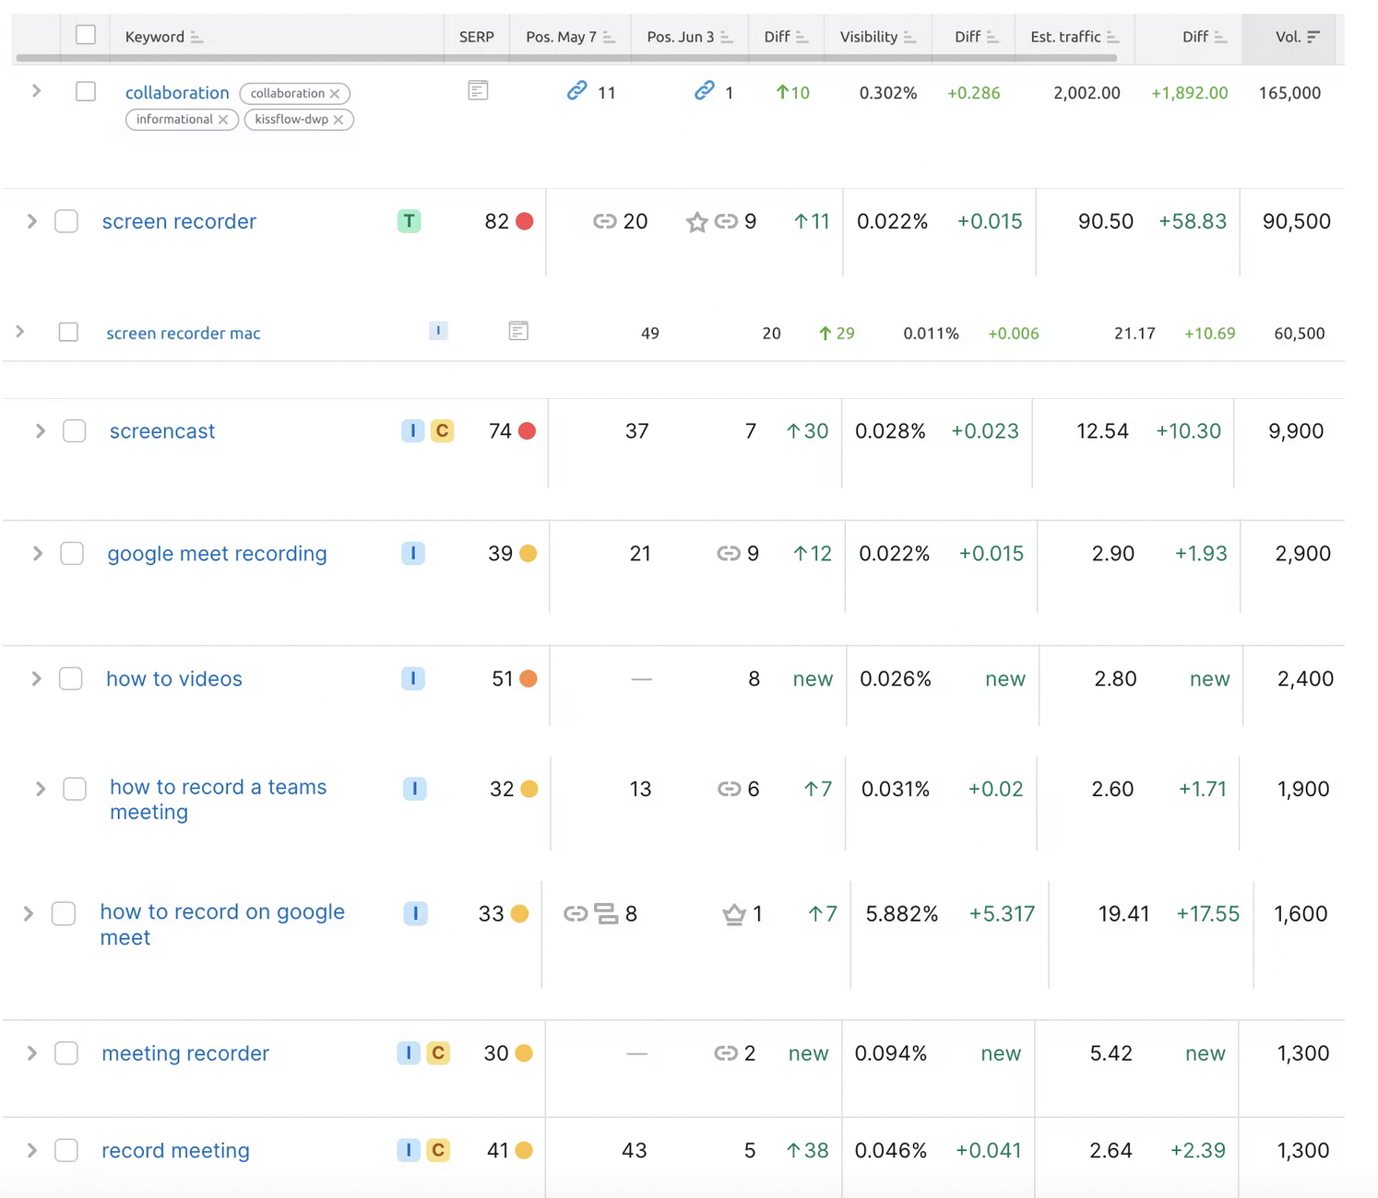

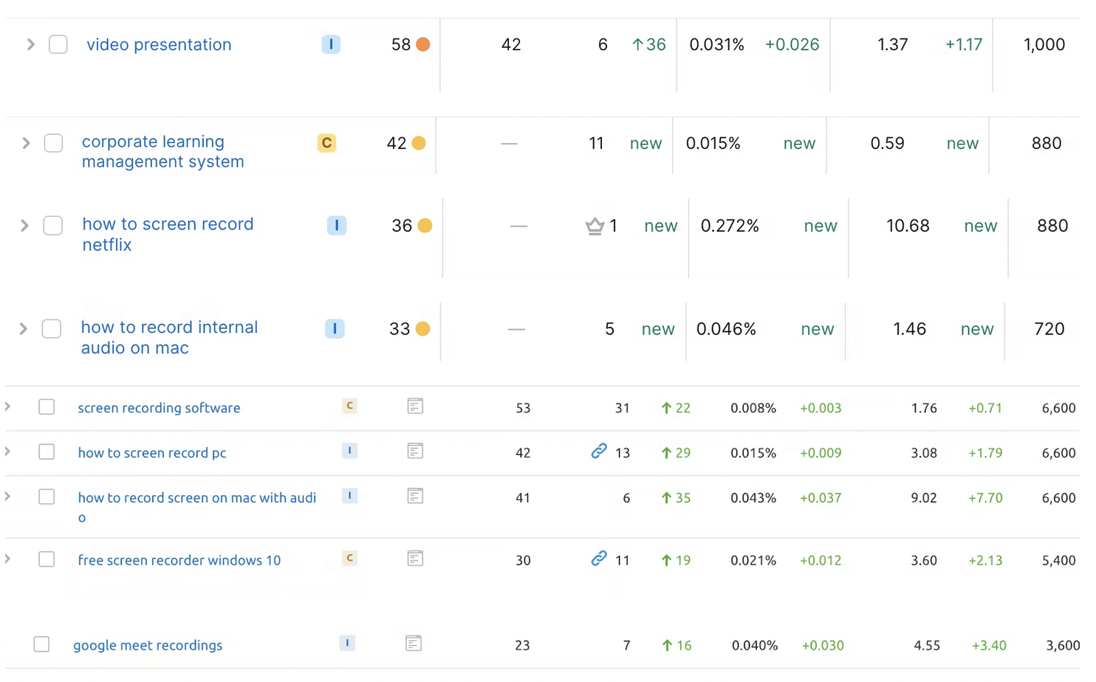

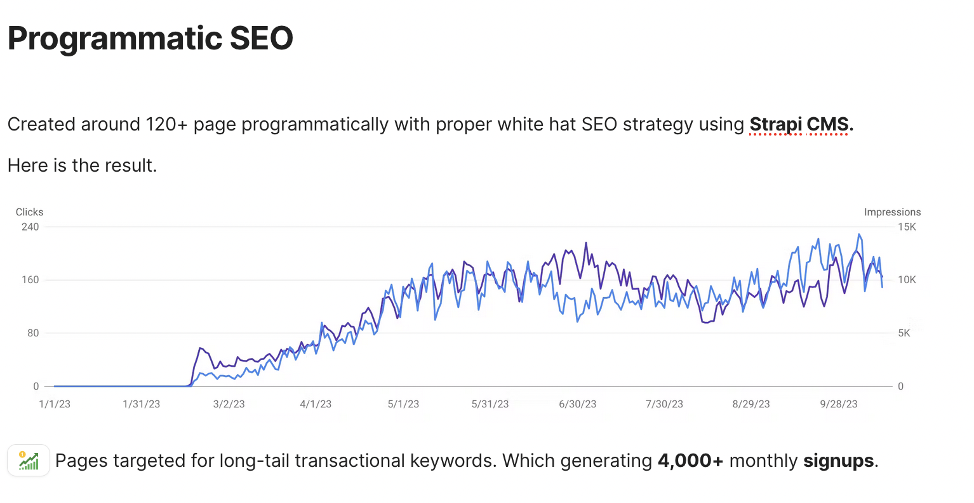

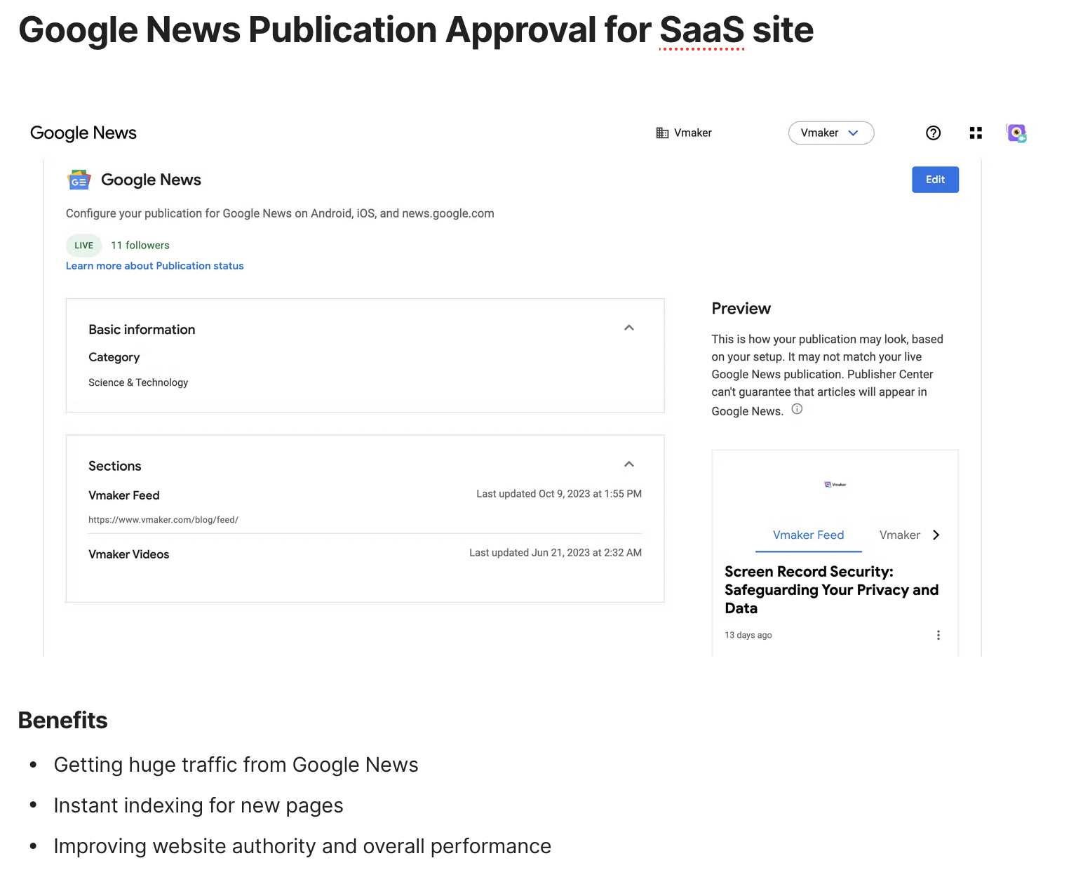

# **Featured Snippet and Rich Snippet**

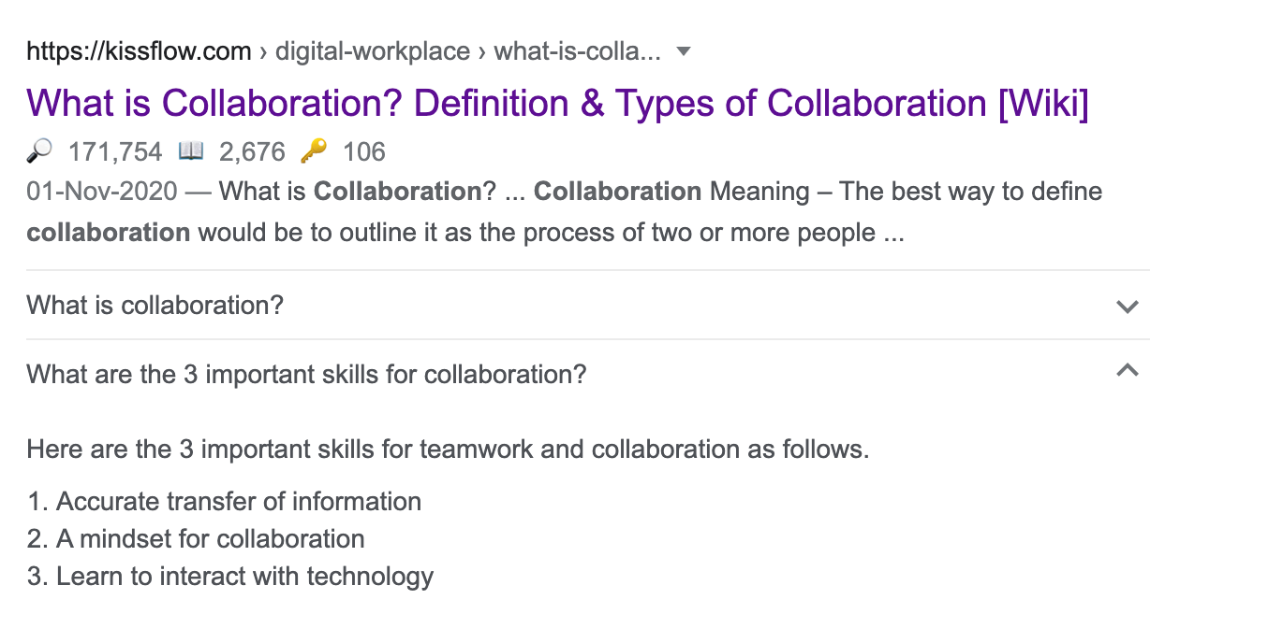

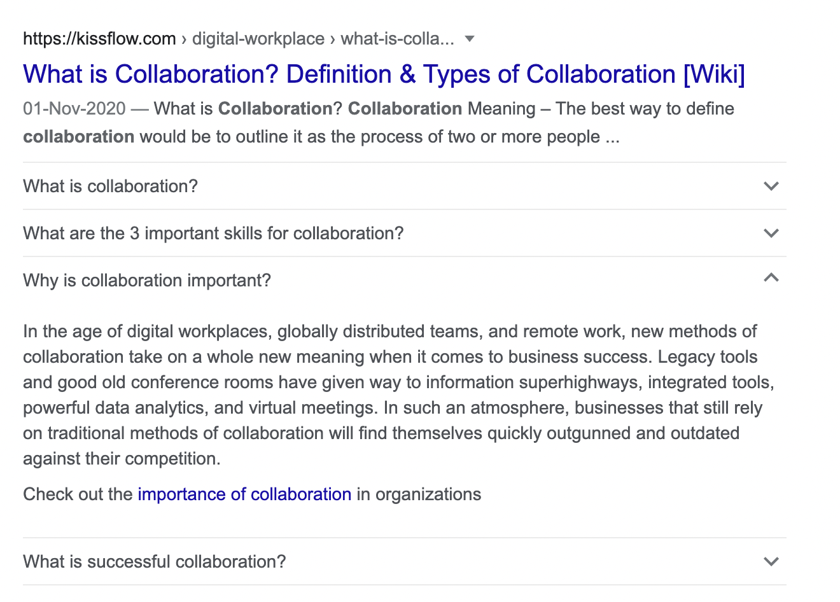

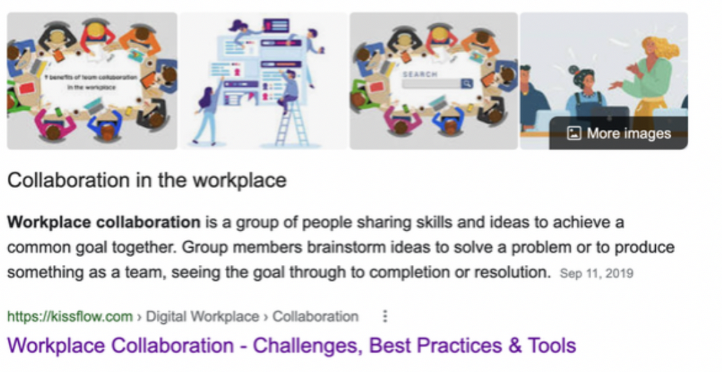

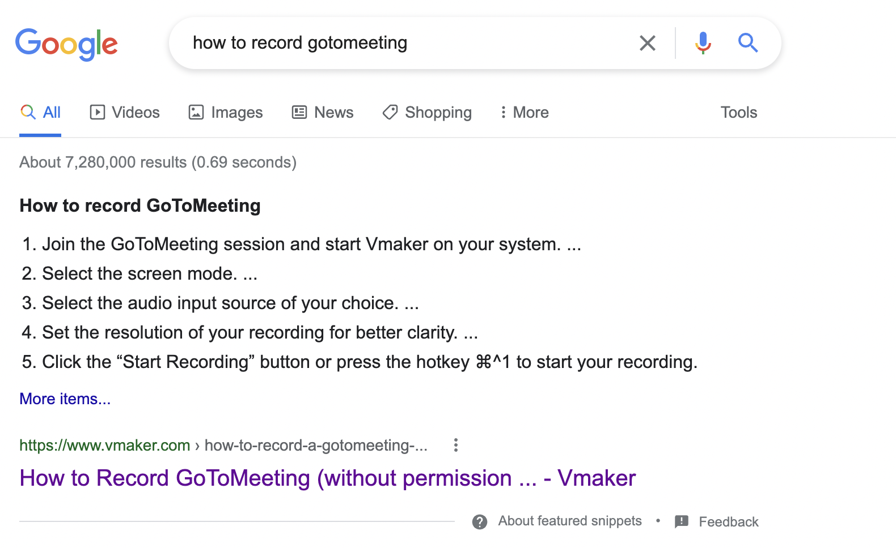

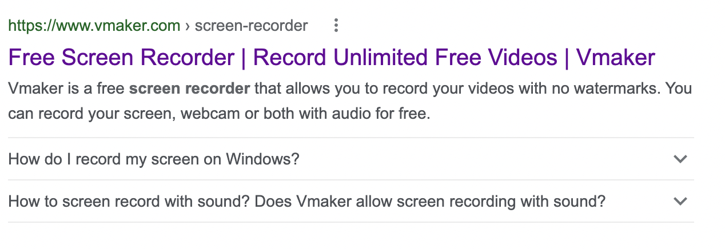

# **Backlinks**

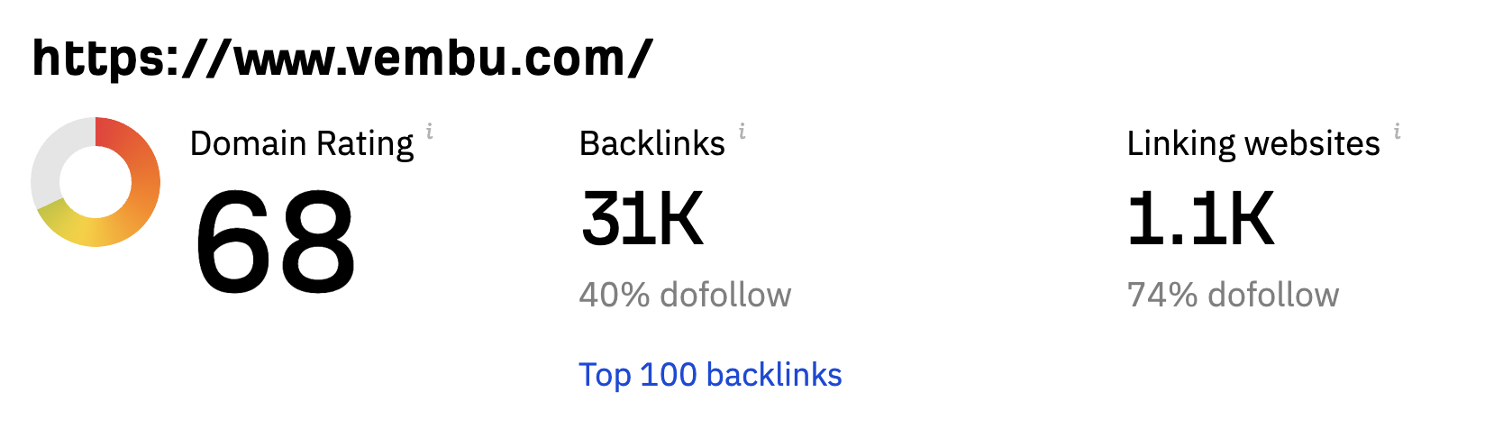

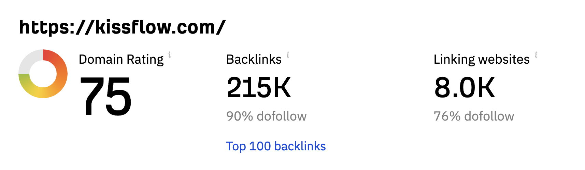

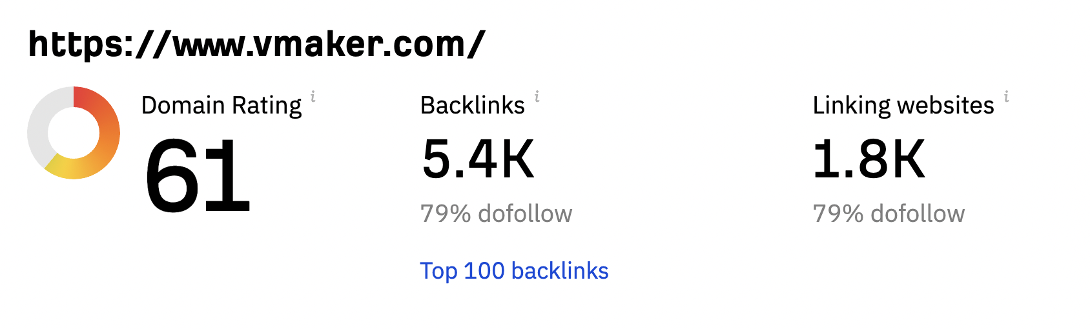

**Vmaker**: Improving DR from 30 to 61 in less than a year.

**Sample backlinks for Vmaker through Outreach:**

<https://clickup.com/blog/free-screen-recorder-no-watermark/>

<https://filmora.wondershare.com/youtube-video-editing/record-screen-and-upload-to-youtube.html>

<https://www.movavi.io/how-to-screen-record-on-mac/>

<https://www.movavi.com/learning-portal/free-screen-recorder-no-watermark.html>

<https://iemlabs.com/blogs/itop-screen-recorder-download-a-comprehensive-review/>

# **ProductHunt Launch**

***Product of the day***

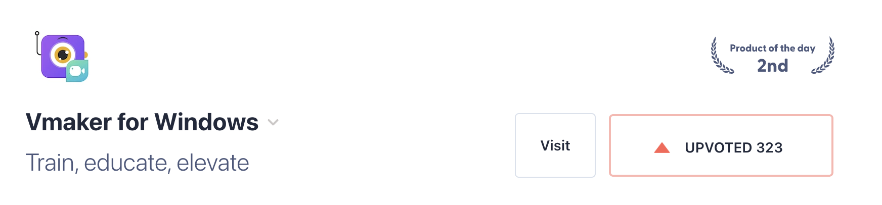

<https://www.producthunt.com/products/vmaker-for-windows>

<https://www.producthunt.com/products/vmaker-for-mac>

<https://www.producthunt.com/products/vmaker-for-chrome>

***Golden Kitty Award - ProductHunt Launch***

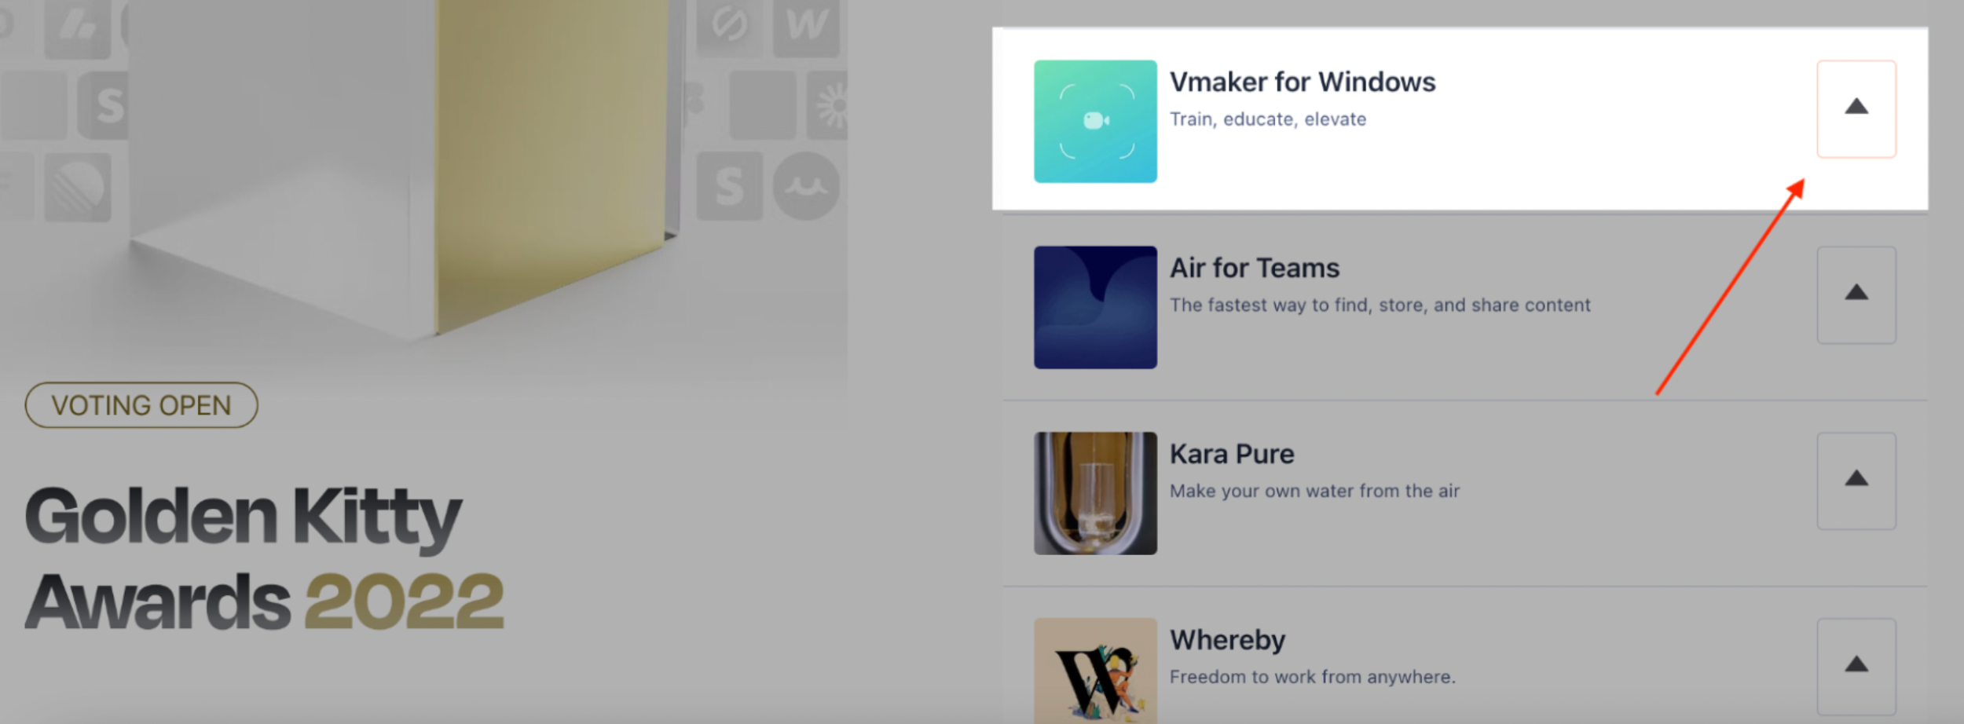

# **Free Press Release Submissions**

<https://www.einpresswire.com/article/593512085/vmaker-launches-its-windows-application>

<https://www.prweb.com/releases/vmaker-launches-its-windows-application-to-take-over-the-screen-recorder-market-892078903.html>

<https://www.pr.com/press-release/870267>

<https://menafn.com/1107052398/Vmaker-Introduces-New-Blur-Tool-To-Shield-Sensitive-Information-From-Prying-Eyes>

<https://prfree.org/@saravanan/vmaker-enhances-data-privacy-introduces-new-blur-tool-to-shield-sensitive-information-from-prying-eyes-7ovp91onif58>

<https://www.1888pressrelease.com/vmaker-enhances-data-privacy-introduces-new-blur-tool-to-sh-pr-726122.html>

<https://www.pr.com/press-release/895490>

# **My Writtings**

<https://www.bdrsuite.com/blog/author/saravananp/>

<https://www.vmaker.com/blog/author/saravanan/>